
FURTHER EDUCATION AND TRAINING CERTIFICATE: INFORMATION TECHNOLOGY: SYSTEMS DEVELOPMENT
ID 78965 LEVEL 4 – CREDITS 165
SUMMATIVE ASSESSMENTS MEMORANDUM
SAQA: 9016
REPRESENT ANALYSE AND CALCULATE SHAPE AND MOTION IN 2-AND 3-DIMENSIONAL SPACE IN DIFFERENT CONTEXTS

FULL NAME & SURNAME
ID NUMBER:
NAME OF ASSESSOR
DATE OF ASSESSMENT
VENUE

 | ACHIEVED | NOT ACHIEVED
KNOWLEDGE
SKILLS

Signature of learner | Signature of Assessor

ASSESSMENT PACK
Please complete the following sections (A and B) before commencing with this assessment. The moderator of this assessment will complete section C.
Section A Learner Information
Name:

Surname:

Date:

Contact telephone no:

Learnership agreement no:

Company: |  |  |  |  |  |  | Site:
ID

Section B Assessor Information
Name:

Surname:

Date:

Contact telephone no:

Assessor no:
Provider no: |  |  |  |  |  |  | Site:
ID

Section C Moderator Information
Name:

Surname:

Date:

Contact telephone no:

Moderator no:
Provider no: |  |  |  |  |  |  | Site:
ID

Results:

PART ONE

Assessors Guide

1. INSTRUCTIONS TO ASSESSOR

INTRODUCTION:

THIS ASSESSMENT GUIDE HAS BEEN DESIGNED AS A GENERIC ASSESSMENT GUIDE AND IS INTENDED FOR USE BY THE ACCREDITED– LEVEL 4 TRAINING PROVIDERS.

PURPOSE OF THE ASSESSMENT

THE PURPOSE OF SUMMATIVE ASSESSMENT AGAINST THIS UNIT STANDARD IS TO:

♦AWARD CREDITS TO THE NQF TO LEARNERS WHO ARE ABLE TO START AND RUN THEIR BUSINESSES.

LEARNING ASSUMPTIONS

THE FOLLOWING KNOWLEDGE, SKILLS, ATTITUDE AND/OR EQUIVALENT:
♦A KNOWLEDGE, COMPREHENSION AND APPLICATION OF LANGUAGE AT NQF 03.

ASSESSMENT METHODS

THE FOLLOWING ASSESSMENT METHODS WILL BE USED FOR THE SUMMATIVE ASSESSMENTS:
♦WRITTEN AND/OR/VERBAL QUESTIONING
♦PRODUCT SAMPLE AND ON SITE ASSESSMENT

2. ASSESSMENT PROCESS

GENERAL
- USE THE ASSESSMENT GUIDE AND YOUR LATEST COMPANY POLICIES AND STANDARD OPERATING PROCEDURES TO ASSESS THE EVIDENCE RECEIVED FROM THE LEARNER.
- USE THE SECTION: ADDITION COMMENTS/QUESTIONS TO NOTE DOWN ANY FURTHER COMMENTS OR QUESTIONS ON THE EVIDENCE ASSESSED.
- USE THE MODEL ANSWERS AS A GUIDELINE TO ASSESS THE LEARNER’S ANSWERS TO THE ASSESSMENT QUESTIONNAIRE.
- THE LEARNER CAN COMPLETE THE ASSESSMENT QUESTIONNAIRE ORALLY. IN THIS CASE, AGREE A DATE, TIME AND VENUE.
- PROVIDE THE LEARNER WITH A FEEDBACK WITHIN 10 WORKING DAYS OF RECEIVING THE EVIDENCE.
STEP 1 - PLANNING FOR THE ASSESSMENT

REVIEW THIS ASSESSMENT GUIDE TO:

- ENSURE THAT YOU UNDERSTAND ALL THE REQUIREMENTS OF THE ASSESSMENT IN TERMS OF EVIDENCE REQUIRED TO PROVE COMPETENCE.
- IDENTIFY AND PREPARE THE LEARNER FOR THE ASSESSMENT BY:

  - COMPLETING THE ASSESSMENT PLAN WITH THE LEARNER TO DISCUSS AND AGREE THE DETAILS REGARDING THE ASSESSMENT.
  - COMPLETING THE ASSESSMENT PREPARATION CHECKLIST AND GETTING THE LEARNER TO SIGN.
- ENSURE THAT YOU HAVE FAMILIARIZED YOURSELF WITH THE FOLLOWING:
  - THE VARIOUS PATROLLING FUNCTIONS AND STANDARD OPERATING PROCEDURES WITHIN THE COMPANY.

STEP 2: COMPLETE THE ASSESSMENT

- COLLECT THE EVIDENCE IN ACCORDANCE WITH THE METHODS AND EVIDENCE REQUIREMENTS SPECIFIED.
- MARK EACH QUESTION AS CORRECT OR INCORRECT IN THE “OFFICE USE” COLUMN.
- RECORD THE EVIDENCE ON THE ASSESSMENT GUIDE AND INDICATE “COMPETENT”, “NOT YET COMPETENT” OR “NOT ASSESSED” FOR EACH ASSESSMENT CRITERION. NOTE DOWN ANY COMMENTS AT THE BACK OF THE ASSESSMENT GUIDE.
- ASK THE LEARNER ADDITIONAL QUESTIONS, IF NECESSARY, TO CLARIFY POINTS. RECORD THESE ON THE GUIDE.
- ALL QUESTIONS MUST BE COMPLETE AS PER THE CRITERIA SPECIFIED.
- ANSWERS PROVIDED MUST BE SIMILAR TO THE MODEL ANSWERS.

STEP 3 - AFTER THE ASSESSMENT

- PREPARE THE FEEDBACK BY WRITING COMPREHENSIVE, DEVELOPMENTAL FEEDBACK AFTER EACH SECTION ON THE ASSIGNMENT SHEETS. IN ADDITION TO THIS, YOU ARE REQUIRED TO WRITE A SUMMARY OVERALL FEEDBACK ON THE ASSESSMENT GUIDE.
- PROVIDE THE FEEDBACK TO THE LEARNER IN A SAFE, UNDISTURBED IN NATURE.
- ENSURE THAT YOUR FEEDBACK IS DEVELOPMENTAL AND SUPPORTIVE IN NATURE.
- ADVISE THE LEARNER ON WHAT ACTION TO FOLLOW IN THE EVENT OF A “NOT YET COMPETENT” RATING.
- ADVISE THE LEARNER ON WHAT ACTION TO TAKE WHERE HE/SHE FEELS THE NEED TO APPEAL AGAINST YOUR DECISION.
- ALLOW THE LEARNER TIME TO PROVIDE YOU WITH FEEDBACK RELEVANT TO THE PROCESS.
- RECORD THE LEARNER’S FEEDBACK IN THE GUIDE AND ENSURE THAT IT IS GIVEN TO THE PERSON RESPONSIBLE FOR THE QUALITY ASSURANCE OF ASSESSMENT TOOLS.
- ENSURE THAT THE LEARNER CO-SIGNS THE ASSESSMENT GUIDE TO INDICATE AGREEMENT WITH THE FEEDBACK.

3. ASSESSMENT DOCUMENTATION REQUIRED:

STEP 1: PLANNING FOR THE ASSESSMENT

♦ASSESSMENT PLAN
♦ASSESSMENT PREPARATION CHECKLIST
♦ASSESSMENT POLICY (INCLUDING APPEALS)
♦EVIDENCE MATRIX
♦ASSESSMENT INSTRUMENTS

STEP 2: CONDUCTING THE ASSESSMENT
♦ASSESSOR GUIDE
♦LEARNER’S WORKBOOK
♦SUMMATIVE ASSESSMENT PACK

STEP 3: AFTER THE ASSESSMENT

♦ASSESSMENT COMMENTS
♦FEEDBACK REPORT

4. SPECIFIC INSTRUCTIONS

PLEASE NOTE THAT PART 3 ASSESSMENT INSTRUMENTS ARE NOT INCLUDED IN THIS GUIDE AND ARE TO BE INCLUDED BY THE ASSESSOR ON AN INDIVIDUAL BASIS.

THE ACTUAL SUMMATIVE ASSESSMENTS NEED TO BE COMPLETED AND SIGNED OFF BY BOTH LEARNER AND ASSESSOR. THE ASSESSOR WILL TAKE CONTROL OF THE COMPLETED ASSESSMENT INSTRUMENTS AND WILL FILE THEM UNDER THE TAB FOR ASSESSMENT EVIDENCE.

THE COMPLETED ASSESSMENT PACK WILL BE KEPT IN SAFEKEEPING AT THE TRAINING PROVIDER FOR THREE MONTHS AFTER ENDORSEMENT BY SETA AND WILL THEN BE RETURNED TO THE LEARNER.

GUIDELINES WHERE AN APPEAL IS LODGED

- THE NORMAL APPEAL PROCEDURE PRESCRIBED BY SETA AND DESCRIBED BY THE PROVIDER’S QUALITY MANAGEMENT SYSTEM WILL BE FOLLOWED.

PART TWO

Assessment Planning

ASSESSMENT PLAN
ASSESSMENT DETAILS
Date of Assessment |  |  |  | Option 1 | Option 2 |  |  |  | Option 3 | Option 4
TIME OF ASSESSMENT
Start: |  |  |  |  |  | End:
VENUE |  |  |  |  |  | Contact  person
LANGUAGE MEDIUM
METHOD OF
METHOD OF ASSESSMENT (please tick off the one to be used)
OBSERVATION |  |  | ORAL |  |  |  |  | WRITTEN
Simulation |  |  | Knowledge test |  |  |  |  | Knowledge test
Product |  |  | Interview

PRE-ASSESSMENT MEETING CHECKLIST
ACTION | YES/NO | COMMENTS
Set learner at ease; be friendly, polite and professional.
Explain to the learner and agree on the
following issues.

- The unit standard that will be assessed
- Date, time, venue and process to be followed during the assessment.
- Summative assessment tools to be used for the assessment.
- The assessment plan
- Purpose of assessment
Explain to the learner and agree on the
role of all involved during the assessment
process.
Identify possible barriers and or disabilities
of the learner.
Explain the meaning and application of
RPL.
Explain, discuss and provide one complete
set of the Appeals process documentation.
Explain to the learner when final results
will be available and how feedback will be
provided.
Discuss previous assessment results if
applicable.

I, ______________________________ (initials and surname of learner), DECLARE THE FOLLOWING:

A copy of the unit standard(s) involved has been given to me prior to this meeting. I know I will be assessed against the criteria, which have been set to the applicable unit standards. The criteria have been discussed with me, and the procedures and purpose of the assessment has been clearly explained to me.

I am well aware of the venue, date and time that I will be assessed. I consider the period of time given to me to prepare myself for the assessment to be fair.

I understand clearly that I have the right to appeal against any decision made by the assessor during the assessment of the evidence provided by me and that I have free access to the appeals procedures attached to this assessment pack. I understand that I have the right to be accompanied by another person during all procedures, and that I have free access to the Training Division of SBV’S Health and Safety Procedures- filed at the offices.

Signature of learner | Date

PART THREE

Assessment Evidence

MEMORANDA

QUESTION 1
The last four semesters an instructor taught Intermediate Algebra, the following numbers of people passed the class.

Answer the following questions.

US REFERENCE: SO 1 AC 1
- Can you identify what measurements are measured with the following instruments and also indicate in what quantities each instrument would measure? Write your answers next to each picture below:
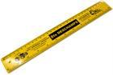



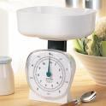

US REFERENCE: SO 2
- If you travel from point A to point B and the distance from one point to the other is 5 km. What will the total distance be which needs to be travelled if one needs to go there and come back 5 times a day over 2 weeks?
lear Notes:
- The distance from point A to point B is 5km. The return distance will also be 5km, therefore totalling 10km.
- If the above distance of 10km per travel needs to be completed 5 times a day it would equal 50km a day.
- 50km a day worth of travelling over two weeks (14 days) will equal:
Total Distance: 700 km
Have a look at the picture below and answer the questions that follow by circling the correct answer/s:

1.3 In the following floor plan of a house, find the perimeter of each room and the perimeter of the entire building (Leave out the porch, bay window and optional storage):
Master bedroom
Master bathroom
Foyer
Dining room
Side entrance at kitchen
Breakfast nook and kitchen
Family room
Entire house

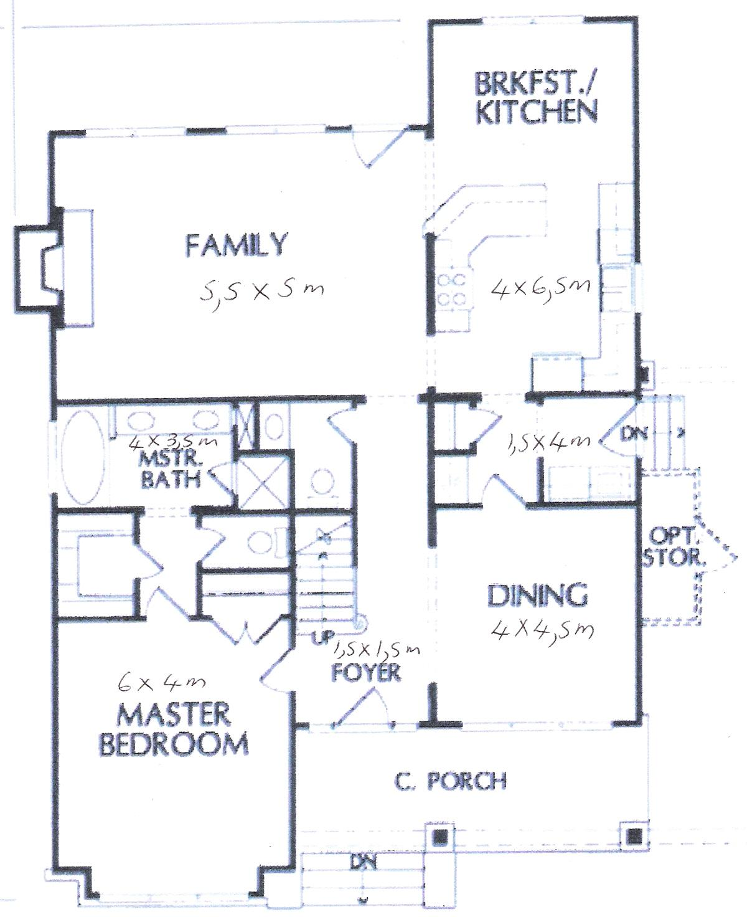

1.4 Calculate the area of each of the rooms in the house:
Master bedroom
Master bathroom
Foyer

Dining room

Side entrance at kitchen

Breakfast nook and kitchen

Family room

In the following floor plan of a house, find the perimeter of each room and the perimeter of the entire building (Leave out the porch, bay window and optional storage):
NB.Tell learners that these plans were drawn up by the homeowner herself from blueprints on the Internet, so there is no consistency in the way the measurements are given. They will have to figure out whether she means width or length in each case by looking at the scale of the drawing.
Master bedroom | 4+4+ 6+6= 20
Master bathroom | 4+4+3,5+3,5=15
Foyer | 1,5+1,5+1,5+1,5= 6
Dining room | 4+4+4,5+4,5=17
Side entrance at kitchen | 4+4+1,5+1,5= 11
Breakfast nook and kitchen | 4+4+6,5+6,5= 21
Family room | 5,5+5,5+5+5=21
Entire house | 6+3,5+ 5+ 1,5+4+6,5+1,5+4,5+4+1,5+1,5+4+ 5,5= 49

1.4 Calculate the area of each of the rooms in the house:
Master bedroom | 4x 6 = 24 m²
Master bathroom | 4x3,5 =14 m²
Foyer | 1,5x1,5 = 2,25 m²
Dining room | 4x4,5 =18 m²
Side entrance at kitchen | 4x1,5 = 6 m²
Breakfast nook and kitchen | 4x 6,5 = 26 m²
Family room | 5,5x5 = 27,5 m²

1.5 At R48.50 a square metre, what is the cost of laying a cement floor in a garage that is 6m long and 4 m wide?
48.50 x 24= R1164

1.6 Write down the formulae for calculating volume for each of the shapes shown

